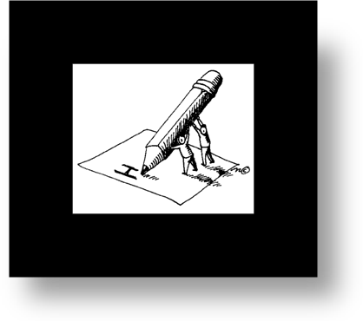
PDP Support Workshop
Survey

- After today’s workshop session, I feel the following way about the PDP process:
- I learned so much and feel prepared to continue work on my PDP.
- I learned some things, but still have a lot of questions.
- I am confused and not sure where to go from here.

- The one-hour overview presented at this workshop was helpful and informative:
- strongly agree b. agree c. neutral d. disagree e. strongly disagree

- The small group, one-on-one time was beneficial and met my expectations for the day:
- strongly agree b. agree c. neutral d. disagree e. strongly disagree

- I still have questions about:
________________________________________________________________________________________________________________________________________________________________________________________________________________________

- This workshop should be offered again for others who are interested or required to complete the PDP process:
- strongly agree b. agree c. neutral d. disagree e. strongly disagree

- Any additional comments?
________________________________________________________________________________________________________________________________________________________________________________________________________________________________________________________________________________________________

Name: (optional) _______________________________________________

